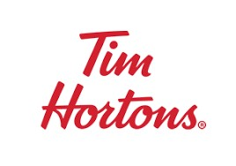& 

**12 DAYS OF CHRISTMAS**

**November 30th till December 11th**

**Help raise funds for Local Healthcare**

**Here’s how to enter for daily draws**

**and the Grand Prize draw on Day 12**

***by making a monetary donation to the***

***Brooks & District Health Foundation***

***by purchasing a dozen Tim Hortons***

***Christmas Chocolate Chip Cookies***

**$10 Gift Card award for those who uncover**

**a dozen cookies with the message ‘HO HO HO’ on them**

**You may also enter for daily draws through**

**‘The Bank Challenge’**

***by bringing an entry form from***

***a participating bank, with your donation***

**Help your favorite bank**

**raise the most funds for Local Healthcare**